Introduction to Machine Learning
Credit: - 3

14/07/2026: - Lecture 1

Subject structure.
Traditional Programming vs Machine Learning
Example: - Credit Risk Estimation, Approach using both TP and ML

Machine Learning Process
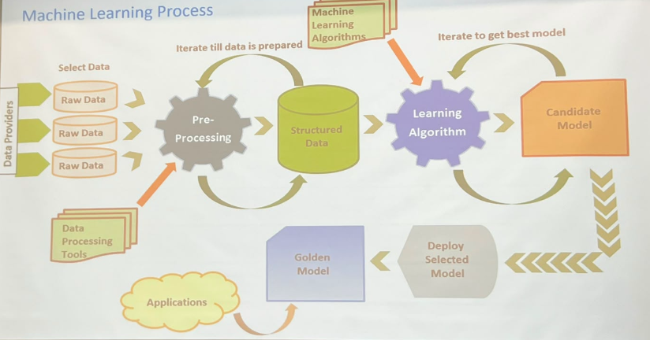

Lecture 2: - 16/07/2026
Types of machine learning

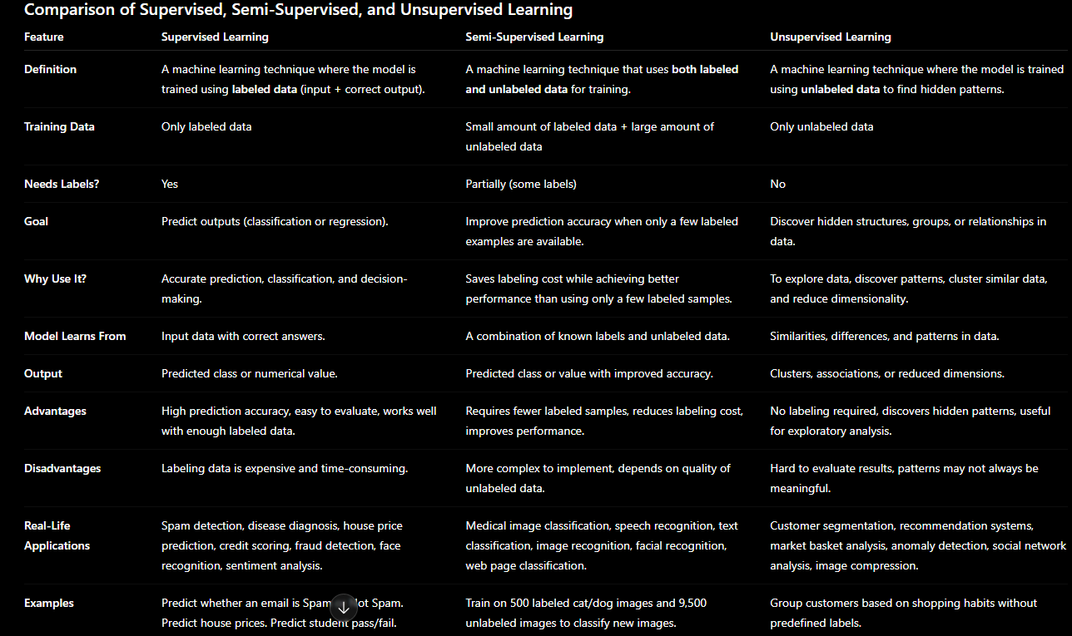

Application of Machine Learning
1.Supervised
Spam filtering, credit-risk scoring

